|  |  |  |
| --- | --- | --- |
|  | **Rochester Institute of Technology**  **Golisano College of Computing and Information Sciences**  **School of Interactive Games and Media**  **2145 Golisano Hall – (585) 475-7680** |  |

**Data Structures & Algorithms for Games & Simulation II**

**IGME 309**

**A04 – Separation Axis Test**

For this assignment, there is starter code provided in the repository, you are not required to use said starting code or the framework for it, you can use your own solution, but it will be your responsibility to translate the provided startup code on your own.

In the class repository, I’ve included a solution under the _Binary folder. Please take a look at that and at the video instructions before continuing reading this document:

<https://youtu.be/_wf2O-EOtIg>

The starter code will give you this out of the box:

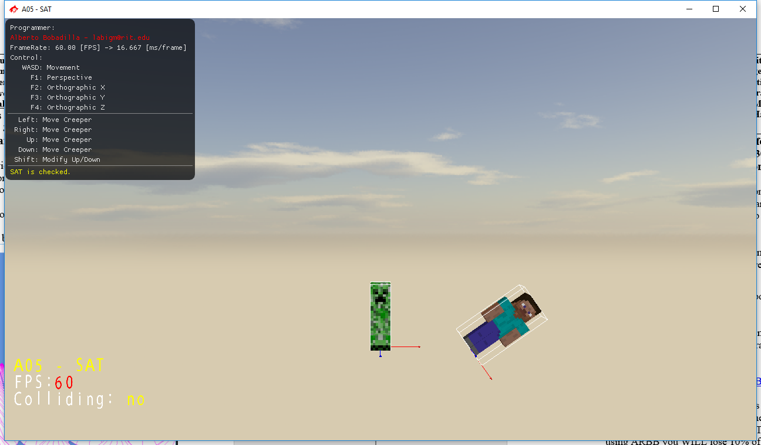

Your grade will be as follows:

100% Detect the collision using the Separation Axis Test explained in class and in the “Real Time Collision Detection” book (the Orange Book).

Deductions will happen as follows:

-20% If you hardcode things.

-20% If you did not comment your code.

If you decide to go for an extra challenge you should write in the ReadMe file what you did as extra and explain and why do you think you deserve the extra points.

20% extra credit (this does override the instructions of ignoring extra credit on assingments) will be given if you generate the 15 separation planes in the right way, partial credit can be given. There is a method for creating planes already working in Simplex through the MeshManager (GeneratePlane).

Controls provided:

WASD will move the camera in a first person shooter kind of movement.

Arrow keys will move the selected model horizontally and vertically, holding shift will move it backwards and forwards

X Y Z to orient the model

F1 to F4 will change the camera

***Submit to the dropbox labeled: A4 – Separation Axis Test***

As usual the required submission asks only for the project folder, not the whole solution, it should be no larger than 200kb if you are using the starter code (and you remove this document from that folder). If you are using your own framework/engine please submit the whole solution. Push your solution to your repository with the comment “**A04 Deliverable**” then zip the project (or solution) and upload it to the dropbox, in the comments section you need to specify the address of your repository.

Example:

